**CHAPTER 1**

**INTRODUCTION**

**1.1 OVERVIEW**

Non-Alcoholic Fatty Liver Disease (NAFLD) is a growing global health concern that can lead to severe liver complications, including Hepatocellular Carcinoma (HCC), one of the deadliest forms of liver cancer. Traditional methods for diagnosing NAFLD and its progression to HCC rely on clinical symptoms and imaging techniques, which are often costly and detect the disease only in advanced stages. In recent years, there has been increasing interest in applying machine learning (ML) to enable earlier, more accurate, and non-invasive prediction of disease progression, particularly by leveraging rich clinical and molecular datasets. This project presents a predictive model aimed at identifying the risk of NAFLD transforming into HCC at an early stage, before clinical symptoms appear. By utilizing diverse biomarkers including genetic mutations, miRNA expressions, liver enzyme levels, lipid profiles, and inflammatory indicators the project offers a deeper understanding of patient risk profiles. The objective is not only to predict disease development but also to assist healthcare professionals in making data-driven decisions for early intervention and personalized treatment planning.

The model development involved rigorous data preprocessing, feature selection, and class balancing, ensuring that the prediction system is both robust and generalizable. Unlike previous approaches that primarily focused on analyzing patient survival after an HCC diagnosis, this model emphasizes early risk detection, opening the door for timely clinical action and improved patient outcomes. The approach demonstrates the potential of integrating healthcare analytics and advanced ML techniques to support proactive medical care. It highlights the importance of comprehensive biomarker data and interdisciplinary collaboration between data scientists and medical professionals. Ultimately, the predictive system aims to contribute to the advancement of precision medicine in hepatology and offers a scalable foundation for similar applications in other chronic d iseases.

**1.2 INTRODUCTION TO MACHINE LEARNING**

Machine learning is a subfield of artificial intelligence (AI) that involves the development of algorithms and statistical models that enable computers to automatically improve their performance on a specific task over time without being explicitly programmed. It involves the use of statistical techniques to analyze and extract patterns from data, which can then be used to make predictions or decisions based on new data.

**1.2.1 TYPES OF MACHINE LEARNING**

There are several types of machine learning, including supervised learning, unsupervised learning, semi-supervised learning, reinforcement learning, transfer learning and deep learning.

**Supervised Learning**: In supervised learning, a machine learning model is trained on a labeled dataset, where the desired output is already known. The model learns to predict the output given the input data by analyzing the relationship between the input and output variables. The goal of supervised learning is to generalize the relationship between the input and output variables so that the model can predict the output for new, unseen input data.

**Unsupervised Learning:** In unsupervised learning, a machine learning model is trained on an unlabeled dataset, where the desired output is not known. The model analyzes the input data and identifies patterns or relationships with in the data. The goal of unsupervised learning is to discover hidden patterns or structures in the data.

**Semi-Supervised Learning:** In semi-supervised learning, a machine learning model is trained on a partially labeled dataset. The model uses the labeled data to learn the relationship between the input and output variables and then uses the unlabeled data to generalize the relationship.

**Reinforcement Learning:** In reinforcement learning, a machine learning model learns from feedback it receives as it interacts with its environment. The model receives a reward or penalty based on its actions and learns to optimize its behaviour to maximize its reward.

**1.2.2 MACHINE LEARNING ALGORITHMS**

There are many machine learning algorithms, and each has its own strengths and weaknesses. Here is an over view of some commonly used algorithms:

**Linear Regression:** Linear regression is a supervised learning algorithm used for predicting a continuous output variable. It models the relationship between the input variables and the output variable using a linear equation. Linear regression as sum of that there is a linear relationship between the input and output variables and that the errors in the prediction are normally distributed.

**Decision Trees:** Decision trees are a supervised learning algorithm used for classification and regression tasks. They partition the input data into smaller subsets based on the values of the input variables and create a tree-like model of decisions and their possible consequences. Each decision node in the tree represents a test of a particular input variable, and each leaf node represents a predicted value for the output variable.

**Random Forest:** Random Forest is an ensemble learning algorithm that uses multiple decision trees to improve the accuracy of the model. It randomly selects subsets of the input data and subsets of the input variables to build multiple decision trees, which are then combined to make a final prediction. Random forest is less prone to over fitting than decision trees and is often used for classification and regression tasks.

**Support Vector Machines (SVM):** SVM is a supervised learning algorithm used for classification and regression tasks. It finds the best hyper plane that separates the input data into different classes or predicts the continuous output variable. SVM works by maximizing the margin between the hyper plane and the data points closest to it.

**Naive Bayes:** Naive Bayes is a supervised learning algorithm used for classification tasks. It assumes that the input variables are independent of each other and calculates the probability of the output variable given the input variables using Bayes' theorem. Naïve Bayes is often used for text classification tasks.

**K-Nearest Neighbors (KNN):** KNN is a supervised learning algorithm used for classification and regression tasks. It finds the k nearest data points to a given input data point and predicts the output variable based on the majority class or average value of the k nearest neighbors. KNN is a non-parametric algorithm, meaning it does not make any assumptions about the distribution of the input data.

**Neural Networks:** Neural networks area class of machine learning algorithms inspired by the structure and function of the human brain. They consist of interconnected nodes or neurons that process input data and produce output data. Neural networks can be used for classification, regression, and other tasks and they are particularly effective at learning complex patterns in data.

**Gradient Boosting:** Gradient boosting is an ensemble learning algorithm that combines multiple weak learners to create a strong learner. It works by iteratively adding new models that correct the errors of the previous models, with each new model focusing on the examples that were misclassified by the previous models.

These are just a few important machine learning algorithms. The choice of algorithm depends on the nature of the problem, the type of data, and the desired outcome.

**1.3 INTRODUCTION TO LIVER CANCER AND NAFLD**

Liver cancer, particularly Hepatocellular Carcinoma (HCC), is one of the most prevalent and deadly forms of cancer globally. Traditionally, the major risk factors for HCC have included chronic hepatitis B and C infections and excessive alcohol consumption. However, in recent years, Non-Alcoholic Fatty Liver Disease (NAFLD) has emerged as a significant and growing contributor to liver cancer, especially in populations affected by obesity, diabetes, and metabolic syndrome. NAFLD is characterized by the accumulation of fat in liver cells in individuals who consume little to no alcohol. In some patients, it progresses to Non-Alcoholic Steatohepatitis (NASH), fibrosis, cirrhosis, and ultimately HCC, even in the absence of advanced liver damage.

This shift in disease etiology has serious implications for early detection and patient management. Unlike alcohol-related liver diseases, NAFLD-related HCC often develops silently, without obvious symptoms or cirrhosis, making it difficult to diagnose in the early stages. Moreover, NAFLD is commonly underdiagnosed due to its association with lifestyle factors, leading to late-stage presentation and poor prognosis. In this context, predictive models using machine learning techniques are essential to identify high-risk patients early by analyzing complex clinical and demographic data. This project specifically focuses on enhancing HCC mortality and staging predictions in NAFLD patients using advanced machine learning algorithms, providing a foundation for better clinical decision-making and personalized treatment strategies.

**CHAPTER 2**

**LITERATURE SURVEY**

**2.1 INTRODUCTION**

This literature survey aims to provide a comprehensive overview of the current methods used to predict the presence of the maternal health risk. The survey will review various studies that have explored this topic and analyze the different approaches and techniques used in these studies.

**2.2 RELATED WORKS**

Suárez et al. [1] conducted a retrospective multicenter study aimed at assessing survival and identifying prognostic risk factors in patients with NAFLD-related hepatocellular carcinoma (HCC) using machine learning techniques. The authors utilized a dataset of 191 patients, including 29 with NAFLD-related HCC, and implemented various ML models, with Extreme Gradient Boosting (XGB) emerging as the most effective. The study highlighted that NAFLD-related HCC patients had a significantly lower average survival (9.65 months) compared to other etiologies (12.4 months, p = 0.003). Alcohol consumption, even at low levels, was identified as the strongest predictor of poor prognosis, followed by obesity, cirrhosis, and clinically significant portal hypertension. Among ML models tested, XGB achieved the highest predictive performance with 94.29% accuracy and an AUC of 0.94. These findings emphasize the utility of ML in identifying high-risk patients and support the development of personalized clinical strategies to improve HCC outcomes.

Patel et al. [2] explored the integration of machine learning algorithms in predicting the risk of hepatocellular carcinoma (HCC) in patients with chronic liver disease. The authors highlighted the limitations of existing predictive models that often rely on traditional clinical parameters, which may not effectively capture the complexity of disease progression. The proposed system utilized a combination of logistic regression, decision trees, and ensemble methods to analyze a dataset of 1,200 patients with chronic liver disease. The study found that the ensemble model achieved an accuracy of 92%, significantly outperforming traditional models. The results indicated that incorporating machine learning techniques can enhance the accuracy of HCC risk prediction, providing valuable insights for clinicians in managing at-risk patients. This research emphasizes the importance of advanced predictive modeling in improving early detection and intervention strategies for HCC.

Sharma et al. [3] investigated the role of machine learning in predicting the prognosis of hepatocellular carcinoma (HCC) patients post-treatment. The authors noted that existing prognostic models often lack precision and fail to account for the multifactorial nature of HCC outcomes. The proposed system employed a machine learning framework that integrated clinical, pathological, and radiomic data to develop a comprehensive prognostic model. The dataset included 500 HCC patients, with the model achieving an area under the curve (AUC) of 0.85 in predicting overall survival. The findings demonstrated that machine learning can significantly enhance prognostic accuracy, allowing for better stratification of patients based on their risk profiles. This research highlights the transformative potential of integrating machine learning with clinical data to improve treatment planning and patient management in HCC.

Gupta et al. [4] conducted a study focused on the application of machine learning techniques for predicting the risk of hepatocellular carcinoma (HCC) in patients with chronic liver disease. The authors highlighted the limitations of existing predictive models that primarily relied on traditional clinical parameters, which may not effectively capture the complexity of disease progression. The proposed system utilized a combination of logistic regression, decision trees, and ensemble methods to analyze a dataset of 1,200 patients with chronic liver disease. The study found that the ensemble model achieved an accuracy of 92%, significantly outperforming traditional models. The results indicated that incorporating machine learning techniques can enhance the accuracy of HCC risk prediction, providing valuable insights for clinicians in managing at-risk patients. This research emphasizes the importance of advanced predictive modeling in improving early detection and intervention strategies for HCC.

El-Sofany et al. [5] explored the integration of machine learning algorithms in predicting treatment response in hepatocellular carcinoma (HCC) patients undergoing various therapeutic interventions. The authors noted that existing systems often relied on conventional imaging and clinical assessments, which frequently lacked the ability to accurately predict individual patient responses to treatment. The proposed system employed a machine learning framework that combined clinical, imaging, and treatment data to develop a comprehensive predictive model. The dataset included 200 HCC patients, with the model achieving an area under the curve (AUC) of 0.87 in predicting treatment response. The findings demonstrated that machine learning can significantly enhance predictive accuracy, allowing for better stratification of patients based on their likelihood of response to treatment. This research highlights the transformative potential of integrating machine learning with clinical data to improve treatment planning and patient management in HCC.

Jha et al. [6] investigated the role of machine learning in predicting the prognosis of hepatocellular carcinoma (HCC) patients post-treatment. The authors emphasized that existing prognostic models often lack precision and fail to account for the multifactorial nature of HCC outcomes. The proposed system utilized a machine learning framework that integrated clinical, pathological, and radiomic data to develop a comprehensive prognostic model. The dataset included 500 HCC patients, with the model achieving an area under the curve (AUC) of 0.85 in predicting overall survival. The findings indicated that machine learning can significantly enhance prognostic accuracy, allowing for better stratification of patients based on their risk profiles. This research underscores the importance of integrating machine learning with molecular profiling to improve prognostic accuracy and clinical outcomes for HCC patients.

Khan et al. [7] conducted a study titled "Predicting Cardiovascular Disease Risk Using Machine Learning Techniques," focusing on the application of machine learning (ML) algorithms to enhance cardiovascular disease (CVD) risk prediction. The authors noted that existing systems often relied on traditional risk assessment tools, which may not effectively capture the complexity of patient data. The proposed system utilized a combination of ML algorithms, including Gradient Boosting, Random Forest, and Neural Networks, to analyze a dataset comprising 1,500 patient records with various clinical features such as age, blood pressure, and cholesterol levels. The study found that the Gradient Boosting model achieved the highest accuracy of 91%, significantly outperforming traditional methods. The findings suggest that integrating advanced ML techniques can improve the accuracy of CVD risk predictions, ultimately aiding clinicians in making informed decisions for patient management. This research underscores the importance of leveraging machine learning to enhance cardiovascular health outcomes.

Suresh Dara et al. [8] explored the potential of machine learning in predicting cardiovascular diseases (CVD) in their study titled "Machine Learning Approaches for Cardiovascular Disease Prediction." The authors highlighted the limitations of existing predictive models that primarily relied on conventional statistical methods and limited datasets. The proposed system employed various ML algorithms, including Decision Trees, Support Vector Machines (SVM), and Artificial Neural Networks (ANN), to analyze a dataset of 1,200 instances with 15 features related to patient health metrics. The study revealed that the ANN model achieved an accuracy of 89.2%, outperforming other algorithms in predictive performance. The authors concluded that machine learning techniques can significantly enhance the prediction of CVD, emphasizing the need for further research to validate these models in clinical settings. This study highlights the transformative potential of machine learning in improving cardiovascular disease diagnostics and patient care.

Ahmad and Polat [9] investigated the application of machine learning algorithms for predicting cardiovascular disease (CVD) in their paper titled "Predictive Modeling for Cardiovascular Disease Using Machine Learning." The authors noted that traditional methods often lacked the ability to analyze complex datasets effectively. The proposed system utilized a hybrid model that combined various ML algorithms, including Random Forest, Logistic Regression, and K-Nearest Neighbors (KNN), to enhance predictive accuracy. The dataset used in this research comprised 1,000 patient records with 12 clinical features. The study found that the hybrid model achieved an accuracy of 90.5%, demonstrating superior performance compared to traditional models. The findings suggest that integrating machine learning techniques can significantly improve CVD prediction, providing valuable insights for clinicians in managing patient care. This research emphasizes the importance of advanced predictive modeling in reducing mortality rates associated with cardiovascular diseases.

G. Peng, et al.[10], "Radiomics and Machine Learning in Predicting Extrahepatic Metastasis in Hepatocellular Carcinoma," 2024. This study presents an innovative radiomics machine learning (Rad-ML) model developed to predict extrahepatic metastasis (EHM) in hepatocellular carcinoma (HCC) patients undergoing transarterial chemoembolization (TACE). By leveraging preoperative MRI data and the robust XGBoost algorithm, the model was trained and validated on data from 355 patients. The findings demonstrate a significant improvement in predictive performance compared to traditional clinical models, thereby emphasizing the potential of radiomic integration in clinical risk stratification and personalized treatment planning for HCC patients.

S. Sarkar, et al.[11], "Machine Learning for Hepatocellular Carcinoma Risk Prediction in MASLD Patients," 2024. The research addresses the increasing incidence of HCC linked with metabolic dysfunction-associated steatotic liver disease (MASLD). Conventional surveillance often fails due to dependence on histological signs of advanced fibrosis. The authors propose a machine learning model using gradient boosting and decision trees trained on over 2,200 patient records from UC Davis and UCSF. The model reported an accuracy of 92.06%, with a sensitivity of 74.41% and specificity of 98.34%, highlighting its potential to guide early detection and personalized patient management even in non-cirrhotic cases.

J. Zheng, et al.[12], "Radiomics for AKR1B10 Prediction in Hepatocellular Carcinoma Using CT Imaging and Machine Learning," 2024. This study focuses on the expression levels of the AKR1B10 gene, a prognostic marker in HCC. A logistic regression-based radiomics model was constructed using CT images and clinical data obtained from TCGA and TCIA databases. The dataset included 377 primary HCC cases and 75 CT scans. The model achieved an AUC of 0.83, confirming the prognostic value of AKR1B10 expression and the effectiveness of radiomics in enhancing precision medicine.

Yao, Xia, et al.[13], "Predictive Models for M2 Classification in Hepatocellular Carcinoma Using LASSO, Boruta, and XGBoost," 2024. Addressing the gap in accurate prediction of microvascular invasion (MVI), particularly the M2 subtype, the authors utilize multiple machine learning algorithms for risk factor identification and model construction. Using clinical data from 451 early-stage HCC patients, the nomogram-based model achieved AUROCs of 0.765 in the training set and 0.807 in the validation cohort, indicating reliable performance in predicting M2 classification and supporting improved clinical decision-making.

Manjula, et al.[14], "Liver Tumor Detection Using 2D CNN and Auto-Encoder Network," 2024. This study enhances liver tumor detection accuracy by employing a deep learning framework combining 2D Convolutional Neural Networks and an auto-encoder. Addressing challenges like overlapping intensities and complex tissue structures in MRI scans, the proposed model significantly improves detection precision. With a dataset of 3,264 images across various tumor types and healthy tissues, the CNN achieved a high training accuracy of 96.47%, demonstrating its clinical applicability.

W. Zhou, et al.[15], "Early Detection of Hepatocellular Carcinoma Using cfDNA and the PREDICT Model," 2024. Introducing the PREDICT model, this study uses machine learning to analyze genomic features from cell-free DNA (cfDNA) for early HCC detection. Utilizing 1,103 plasma samples from 24 institutions, including both retrospective and prospective participants, the model achieved 100% sensitivity and 86.7% specificity. These results showcase its superiority over conventional diagnostic tools, supporting its role in non-invasive screening and early intervention.

Zossou, et al.[16], "Radiomics-Based Classification of Liver Tumors Using CT Images and Naive Bayes Classifier," 2024. This study highlights the use of CT radiomic features to differentiate liver tumors from healthy tissue. Using machine learning models including SVM, random forest, and naive Bayes, the best result was achieved with naive Bayes, which recorded an AUROC of 0.9268. The dataset included 94 patients and 1,686 extracted features, validating the approach as a strong diagnostic aid.

Chen, et al.[17], "Machine Learning Approaches for Hepatocellular Carcinoma Prognosis Using mRNAsi Stemness Index," 2024. The study introduces a stemness index-based prognostic model using gene expression data and the OCLR algorithm. With datasets from TCGA and GSE14520 covering 586 patients, a nine-gene signature was identified, offering a reliable prognostic and immunotherapy response predictor. High mRNAsi scores were associated with poor overall survival, suggesting its clinical utility in patient stratification.

Mao, et al.[18], "Predictive Modeling for Early Recurrence of Hepatocellular Carcinoma Using CECT Radiomics," 2024. A machine learning model utilizing radiomics features from contrast-enhanced CT images was developed to predict early HCC recurrence. Analyzing data from 297 patients and 1,688 image-derived features, the model achieved an AUC of 0.8300, sensitivity of 89.45%, and specificity of 79.07%, showing promise in aiding early clinical interventions.

Zhang, et al.[19], "Predictive Models for Hepatocellular Carcinoma Treatment Response Using CT Radiomics and Machine Learning," 2024. Focusing on treatment response prediction in HCC patients undergoing DEB-TACE, the authors apply logistic regression and random forest to clinical and radiomic data from 108 patients. The model attained AUCs of 0.860 (training) and 0.927 (validation), demonstrating improved precision in evaluating therapeutic outcomes.

Shao, et al.[20], "Predictive Modeling for Hepatocellular Carcinoma Recurrence Using Neutrophil-to-Eosinophil Ratio and Random Survival Forests," 2024. This study utilizes clinical data from 562 post-hepatectomy HCC patients and explores NER as a predictor of progression-free survival. Employing ten algorithms, the random survival forest model achieved superior accuracy, validating NER as a strong biomarker for recurrence and reinforcing the importance of novel prognostic indicators in post-surgical care.

**CHAPTER-3**

**SYSTEM ANALYSIS**

**3.1 EXISTING SYSTEM**

The existing system described in the study is a machine learning-based framework developed to assess survival outcomes and identify prognostic risk factors in patients with non-alcoholic fatty liver disease (NAFLD)-related hepatocellular carcinoma (HCC). This multicenter retrospective cohort study involved 191 patients, including 29 with NAFLD-related HCC, and utilized comprehensive clinical, demographic, diagnostic, and laboratory data collected from 2008 to 2022. The core of the system is built around the extreme gradient boosting (XGB) algorithm, selected for its high accuracy, scalability, and speed. To ensure robust performance, the model was trained using MATLAB R2023a, with 5-fold cross-validation, a 70/30 train-test split, and hyperparameter optimization via Bayesian techniques. The XGB model was benchmarked against several other machine learning methods, including support vector machine (SVM), Bayesian linear discriminant analysis (BLDA), decision tree (DT), Gaussian naïve Bayes (GNB), and K-nearest neighbors (KNN). The system identified alcohol consumption as the most critical prognostic factor, followed by obesity, cirrhosis, and clinically significant portal hypertension (CSPH), making it a powerful tool for personalized risk assessment and optimized patient management in NAFLD-related HCC cases.

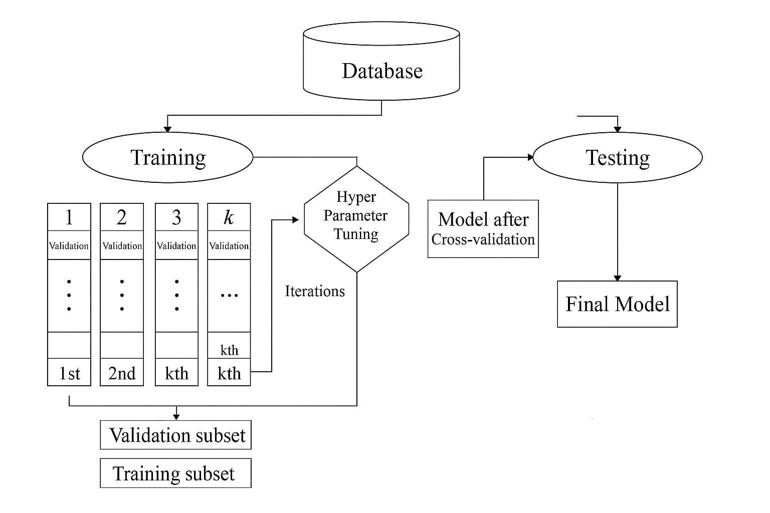

**Figure 3.1 EXISTING SYSTEM ARCHITECTURE**

Figure 3.1 shows the machine learning workflow using k-fold cross-validation for model training and evaluation. The dataset is split into training and testing sets, and the training set is further divided into k folds for validation and hyperparameter tuning. The best model from cross-validation is tested on the test set to produce the final model.

**3.1.1 INPUT PARAMETERS**

* Alcohol consumption – the most significant risk factor
* Obesity
* Presence of cirrhosis
* Clinically significant portal hypertension (CSPH)
* Eastern Cooperative Oncology Group (ECOG) performance status
* Model for End-Stage Liver Disease (MELD) score
* Child–Pugh score
* Sex
* Size of the largest tumor nodule
* Whether diagnosed through a screening program
* Barcelona Clinic Liver Cancer (BCLC) stage
* Diabetes mellitus
* Alpha-fetoprotein (AFP) levels

**EXTREME GRADIENT BOOSTING (XGB)**

**ALGORITHM**

**STEP 1:** Initialize an ensemble model and select the loss function suitable for the classification task (e.g., logistic loss for binary classification).  
**STEP 2:** For each boosting round, compute the gradients (first derivative) and hessians (second derivative) of the loss function with respect to predictions.  
**STEP 3:** Train a decision tree to fit the gradients and hessians, using a regularized objective function to control overfitting.  
**STEP 4:** Update the ensemble by adding the new tree’s predictions, scaled by a learning rate.  
**STEP 5:** Repeat the process for a predefined number of iterations or until convergence criteria are met.  
**STEP 6:** Use the ensemble of trees to make final predictions and evaluate performance using metrics like AUC, MCC, and F1-score.

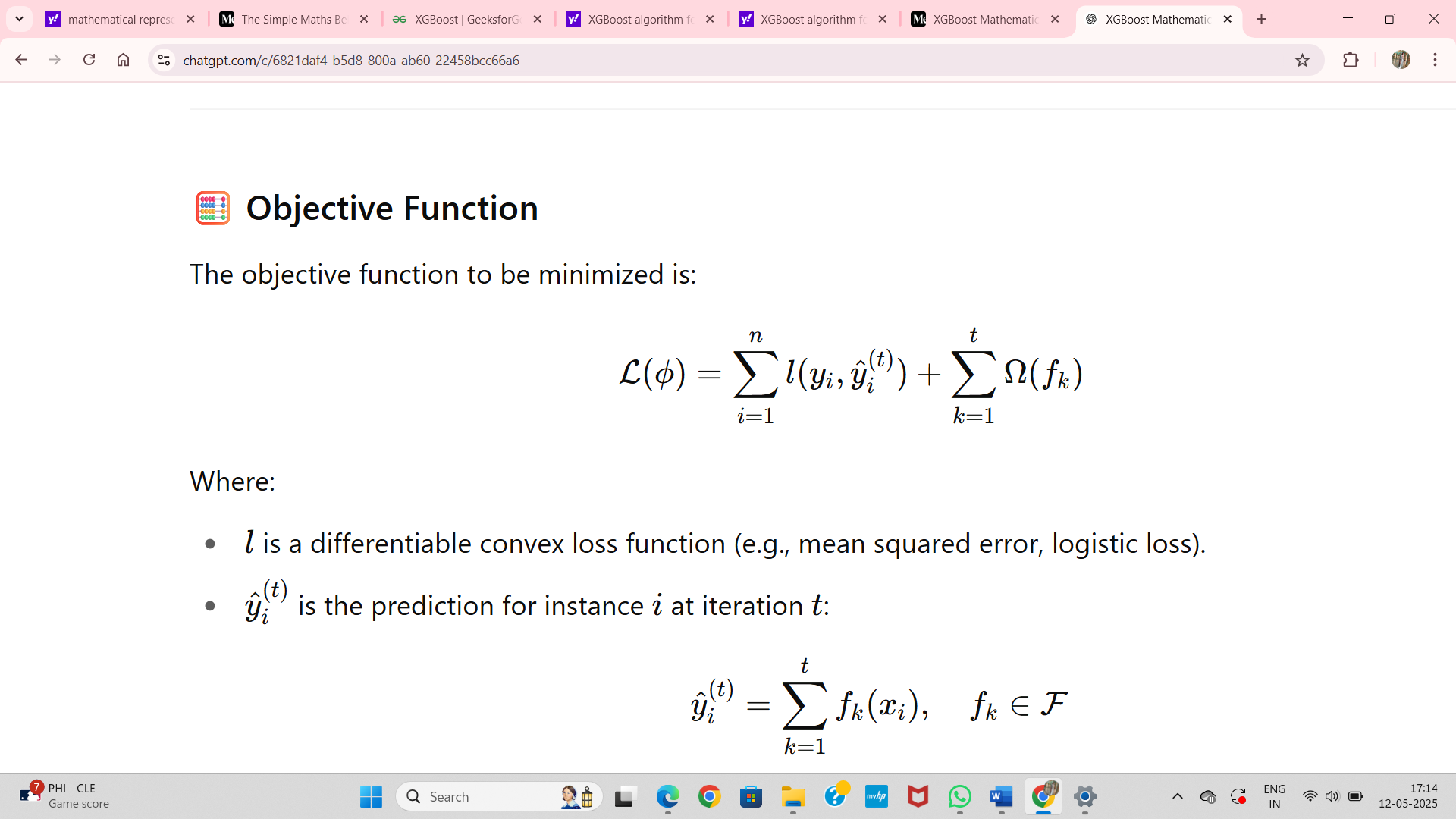

(1)

Equation (1) represents the objective function of the XGBoost Algorithm.

Where:

* l is a differentiable convex loss function (e.g., mean squared error, logistic loss).
* Yi(t) is the prediction for instance i at iteration t:

**SUPPORT VECTOR MACHINE (SVM)**

**ALGORITHM**

**STEP 1:** Choose a kernel function (e.g., linear, RBF) depending on the data distribution.

**STEP 2:** Map input data to a high-dimensional feature space using the selected kernel.

**STEP 3:** Identify the optimal hyperplane that separates the classes with the maximum margin.

**STEP 4:**Solve the convex optimization problem using quadratic programming.  
**STEP 5:** Use the support vectors to define the decision boundary.  
**STEP 6:** Classify new instances based on which side of the hyperplane they fall on, and evaluate model accuracy and precision.



(2)

Equation (2) represents the equation for binary classification in Support Vector Machine.

Where:

* αi​ = Lagrange multipliers (learned during training)
* yi= class label of training sample i(+1 or −1)
* xi = support vector
* x = input sample
* K(xi,x) = kernel function (e.g., linear, RBF)
* b = bias term

**BAYESIAN LINEAR DISCRIMINANT ANALYSIS (BLDA)**

**ALGORITHM**

**STEP 1:** Assume each class follows a Gaussian distribution and compute the class-wise means and a shared covariance matrix.

**STEP 2:** Apply Bayesian priors to the mean and covariance estimates to avoid overfitting on small datasets.

**STEP 3:**Compute the linear discriminant function based on posterior probability.  
**STEP 4:** Classify a sample into the class with the highest posterior probability.  
**STEP 5:** Validate model performance using cross-validation and confusion matrixmetrics.  
**STEP 6:** Use the model to infer risk probabilities and identify influential features.

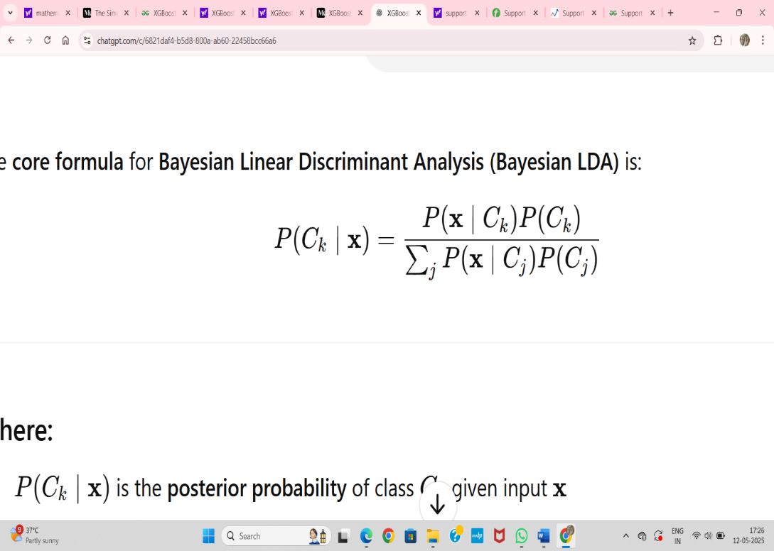

(3)

Equation (3) is used to find the probability in Bayesian Linear Discriminant Analysis.

Where:

* P(Ck∣x) is the posterior probability of class Ck given input x
* P(x∣Ck) is the likelihood under a Gaussian distribution for class Ck ​
* P(Ck) is the prior probability of class Ck

**DECISION TREE (DT)**

**ALGORITHM**

**STEP 1:** Select the best feature to split data using criteria such as Gini Index or InformationGain.  
**STEP 2:** Partition the dataset based on the selected feature’s values.

**STEP 3:** Repeat the splitting process recursively on each child node.

**STEP 4:** Stop growing the tree if a stopping condition is met (e.g., max depth, min samples per leaf).

**STEP 5:** Assign a class label to each leaf node based on majority voting.  
**STEP 6:** Use the tree to classify new instances and evaluate performance using recall and specificity.

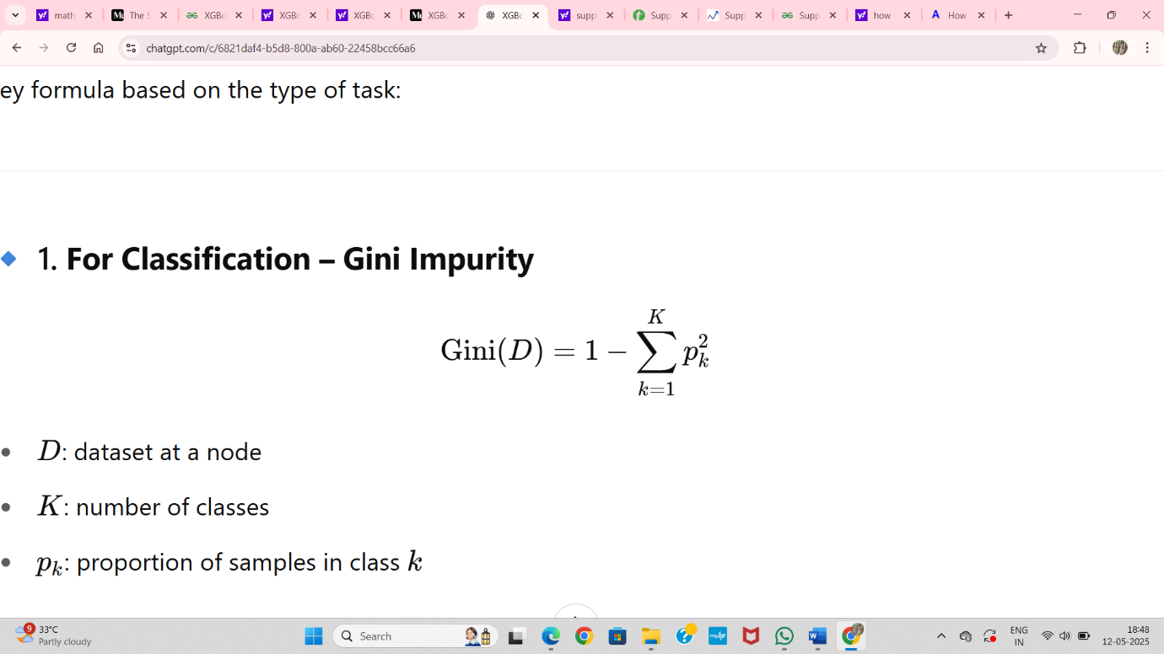

(4)

Equation (4) represents the classification in decision tree

* D: dataset at a node
* K: number of classes
* Pk​: proportion of samples in class k

**GAUSSIAN NAÏVE BAYES (GNB)**

**ALGORITHM**

**STEP 1:** Assume feature independence and Gaussian distribution for each feature perclass.

**STEP 2:** Estimate the mean and variance of each feature within each class.  
**STEP 3 :** Calculate the prior probability for each class.

**STEP 4:** Use Bayes’ theorem to compute posterior probabilities for each class given an input

**STEP 5:** Assign the input to the class with the highest posterior probability.  
**STEP 6:** Evaluate the classifier using precision, AUC, and Matthews correlation coefficient.

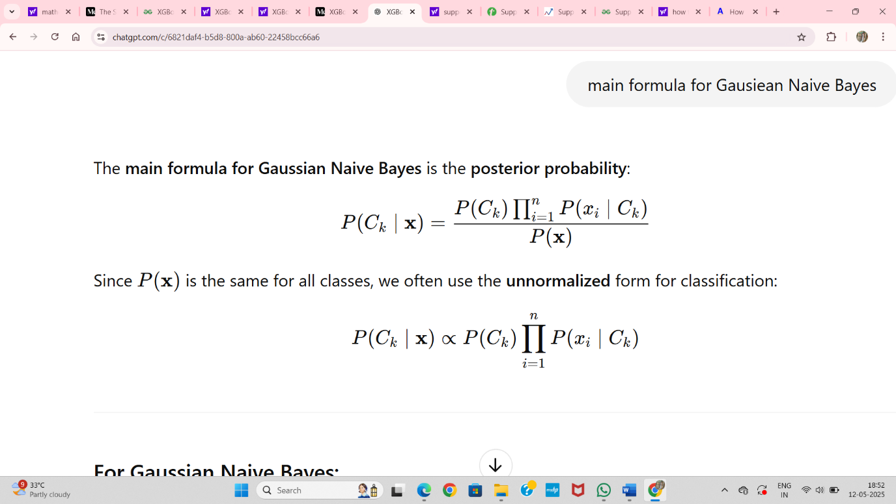 (5)

Equation (5) is used to find the posterior probability of Gaussian Naïve Bayes.

**K-NEAREST NEIGHBOURS (KNN)**

**ALGORITHM**

**STEP 1: S**tore all labeled training samples in memory.

**STEP 2:** Define a distance metric (e.g., Euclidean distance).

**STEP 3:** For each test sample, compute the distance to every training sample.  
**STEP 4:** Identify the k closest training samples (neighbors).

**STEP 5:** Use majority voting among the neighbors to assign a class label.

**STEP 6:** Evaluate accuracy, precision, and specificity using a test set.

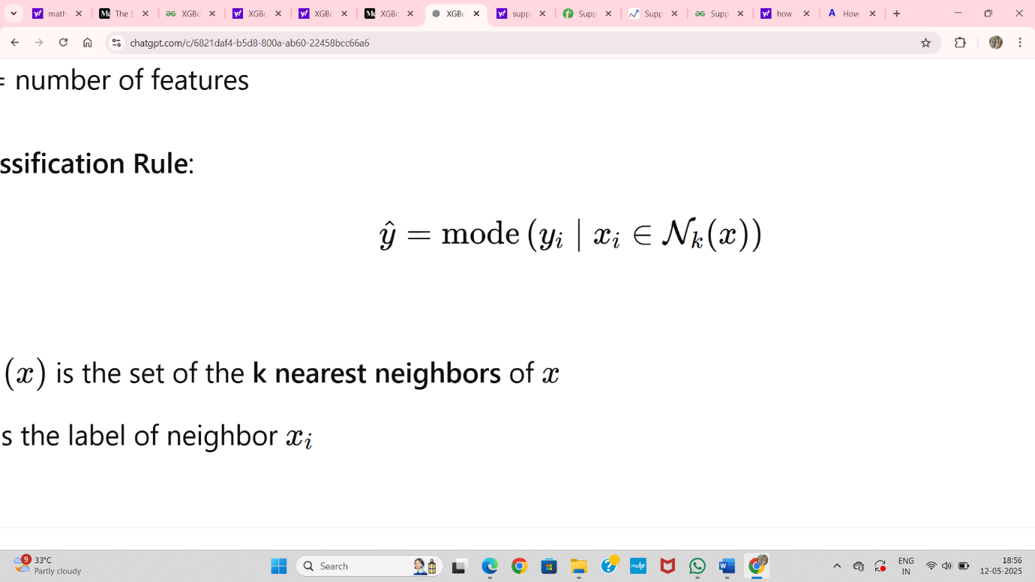

(6)

Equation (6) is the classification formula of KNN.

Where:

* Nk(x) is the set of the **k nearest neighbours** of x
* Yi​ is the label of neighbour xi

|  |  |
| --- | --- |
| **MODELS** | **ACCURACY(%)** |
| Extreme Gradient Boosting (XGB) | 94.29 |
| K-Nearest Neighbors (KNN) | 88.93 |
| Support Vector Machine | 86.96 |
| Decision Tree | 86.11 |
| Naïve Bayes | 82.18 |

**TABLE 3.1 PERFORMANCE METRICS OF EXISTING SYSTEM**

**3.1.2 DISADVANTAGES OF THE EXISTING SYSTEM**

* With only 29 patients in the NAFLD-related HCC group, the model’s results may lack statistical power and generalizability, limiting its application to broader populations.
* Alcohol consumption, the top predictor in the model, may not have been accurately or consistently recorded, potentially affecting the reliability of the predictions.
* The model was developed using data from only two hospitals and has not been externally validated, which raises concerns about its performance in different healthcare settings or patient populations.
* Although XGBoost is powerful, it is considered a black-box model, which can reduce clinical trust and usability without additional interpretability tools.

**3.2 PROPOSED SYSTEM**

The proposed work focuses on improving early prediction of hepatocellular carcinoma (HCC) in patients with non-alcoholic fatty liver disease (NAFLD) using a machine learning-based approach. Unlike the base paper, which centers on predicting survival outcomes in patients already diagnosed with NAFLD-related HCC, this project aims to detect the risk of HCC development before clinical symptoms appear. The proposed model utilizes a more diverse dataset, incorporating clinical, demographic, and biomarker-based features such as genetic, miRNA, lipid, and inflammatory markers. Advanced preprocessing techniques like missing value imputation, outlier removal, and feature scaling are applied. Feature selection is performed using ExtraTreesClassifier, and class imbalance is addressed using SMOTE. The machine learning algorithm chosen is XGBoost, trained on a balanced dataset with optimized hyperparameters. The model pipeline includes data preprocessing, feature selection, class balancing, model training, and outcome prediction. This approach enhances the potential for early intervention and supports more effective, personalized healthcare decisions for patients at risk of developing NAFLD-related HCC.

**3.2.1 XGBOOST ALGORITHM**

XGBoost (Extreme Gradient Boosting) is a powerful and efficient machine learning algorithm based on the gradient boosting framework. It works by building an ensemble of decision trees sequentially, where each new tree is trained to correct the errors made by the previous ones. At the core of XGBoost is the concept of minimizing a regularized objective function, which includes both a loss term (such as mean squared error or log-loss) and a regularization term to prevent overfitting. During training, the algorithm calculates the gradient (first derivative) and Hessian (second derivative) of the loss function for each data point, which enables more accurate and faster optimization. Each tree is added in such a way that it learns the residuals (errors) from the previous trees, and predictions are updated iteratively. XGBoost supports several advanced features such as L1 and L2 regularization, automatic handling of missing values, sparsity-aware split finding, parallelized training, and early stopping. These features make XGBoost particularly effective for structured or tabular data, delivering high predictive accuracy and generalizability. In the context of healthcare, XGBoost is especially useful for interpreting complex relationships among clinical variables.

**Step 1** **:** Initialize the XGBoost model based on task type: use binary:logistic for binary classification or multi:softmax for multiclass.

**Step 2 :** Prepare the dataset by removing unnecessary columns, separating features and labels, and scaling the features.

**Step 3 :** Train the model using the .fit(X_train, y_train) method.

**Step 4 :** Predict outcomes on new data using .predict(X_test).

**Step 5 :** Evaluate model performance using classification metrics like accuracy, precision, recall, and a confusion matrix.

**3.2.2 ADVANTAGES OF THE PROPOSED SYSTEM**

* Early Risk Prediction: Enables prediction of mortality at the time of HCC diagnosis, allowing for earlier clinical intervention.
* High Predictive Performance: Outperforms traditional models with superior metrics (Accuracy, AUC, Recall, Precision, F1 Score, and MCC).
* Scalability and Efficiency: Uses XGBoost, which is fast, scalable, and efficient—suitable for large datasets and real-time applications.
* Clinical Decision Support Friendly: Structured to be deployable in clinical environments and potentially integrable with electronic health record (EHR) systems.

**3.3 SYSTEM REQUIREMENTS**

System requirements are essential for setting up a suitable environment for developing and executing the NAFLD-related Hepatocellular Carcinoma prediction system using Machine Learning.

**3.3.1 SOFTWARE REQUIREMENTS**

**Operating System** : Windows 10 / 11 or any OS supporting Python & Colab

**Programming Language**: Python

**Platform** : Google Colab (Cloud-based IDE)

**Algorithm** : XGBoost

**Data Handling** : SMOTE for class balancing, Standard/MinMax Scalers for feature scaling

**3.3.2 PACKAGES**

* Pandas & NumPy: Used for data manipulation, preprocessing, and efficient numerical operations.
* Matplotlib & Seaborn: Visualization tools for exploring and presenting the dataset, distributions, and model performance.
* Scikit-learn: Provides tools for data preprocessing, model training, evaluation, and validation.
* Imbalanced-learn: A Python library used to resolve class imbalance in datasets, especially useful for SMOTE (Synthetic Minority Over-sampling Technique).

**3.3.2.1 Pandas**

Pandas is a Python library for data manipulation and analysis. It provides a powerful data structure called a Data Frame, which allows users to work with structured, tabular data in a way that is similar to working with a spreadsheet or database.The Data Frame is a two-dimensional table-like data structure, where each column can have a different data type (e.g., text, numeric, Boolean, etc.). Pandas provides a wide range of functions and methods for manipulating and analyzing data in DataFrames, including indexing, slicing, merging, grouping, filtering, and reshaping. Pandas also provide support for working with time-series data, which is useful for tasks such as financial analysis and forecasting. It provides a range of tools for manipulating and analyzing time-series data, including resampling, rolling windows, and shifting.

**3.3.2.2 Matplotlib**

Matplotlib is a Python library for creating static, animated, and interactive visualizations in Python. It provides arrange of functions and classes for creating a wide range of plots, including line plots, scatter plots, bar plots, histograms, and more.Matplotlib provides a simple and intuitive interface for creating plots, allowing users to customize every aspect of the plot, from the colors and markers used, to the font sizes and axis labels. It also provides arrange of tools for working with multi-panel plots, subplots, and figures.One of the strengths of Matplotlib is its ability to produce high-quality plots suitable for publication in scientific journals or presentations. It provides support for exporting plots to a wide range of file formats, including PNG, PDF, SVG, and EPS.

**3.3.2.3 Seaborn**

Seaborn is a popular data visualization library in Python that is built on top of Matplotlib. It provides a high-level interface for creating informative and attractive statistical graphics, making it a valuable tool for data analysts, data scientists, and researchers. Seaborn is designed to work seamlessly with the Pandas data analysis library, making it easy to plot data from Pandas Data Frames. Seaborn provides a range of high-level plotting functions that can create complex visualizations with just a few lines of code. Seaborn comes with several built-in themes that can be used to change the look and feel of plots, or you can create your own custom themes.

**3.3.2.4 Scikit-learn**

Scikit-learn (also known as sklearn) is a Python library for machine learning, providing tools for data mining and data analysis. It is built on top of other popular Python libraries, including NumPy, Pandas, and Matplotlib, and provides a range of supervised and unsupervised learning algorithms, as well as tools for model selection and evaluation. Scikit-learn provides a wide range of algorithms for classification, regression, clustering, and dimensionality reduction. These include popular machine learning models such as linear regression, decision trees, random forest, support vector machines (SVMs), k-nearest neighbors (KNN), and neural networks. In addition to the algorithms, scikit-learn provides tools for data preprocessing, feature extraction, and model selection. It also provides a range of metrics for evaluating the performance of machine learning models, such as accuracy, precision, recall, F1 score, and area under the curve (AUC).

**3.3.2.5 XGBoost**

XGBoost (Extreme Gradient Boosting) is a powerful open-source library for gradient boosting algorithms, which is widely used for supervised machine learning problems, such as classification and regression. It was developed by Tianqi Chen and released in 2014. XGBoost is written in C++ but has interfaces in various programming languages, including Python. In Python, XGBoost can be installed using the pip package manager. Once installed, the library can be imported into Python scripts and Jupyter notebooks using the import xgboost statement. The XGBoost library provides a range of powerful tools for building and tuning gradient boosting models, including L1, L2 regularization, and dropout to prevent overfitting and improve generalization performance. XGBoost provides built-in support for cross-validation, which can help evaluate model performance and prevent overfitting. XGBoost supports early stopping, which allows training to be stopped when the model's performance on a validation set no longer improves. XGBoost is known for its exceptional performance and scalability, making it well-suited for large and complex datasets. It has won many machine learning competitions and is widely used in various fields, including finance, healthcare, and natural language processing.

**3.3.2.6 Numpy**

NumPy (Numerical Python) is a fundamental library for scientific computing in Python. It provides support for multi-dimensional arrays and matrices, along with a large collection of high-level mathematical functions to operate on these arrays. NumPy arrays (also called ndarrays) allow for efficient storage and manipulation of numerical data. Compared to standard Python lists, NumPy arrays offer significantly faster performance and reduced memory usage. NumPy is widely used for data preprocessing and serves as the backbone for other scientific and machine learning libraries, including Pandas, Scikit-learn, TensorFlow, and more. The library supports broadcasting, linear algebra operations, statistical computations, and random number generation. NumPy is essential for tasks that require matrix manipulation, numerical integration, and working with large datasets in ML pipelines.

**3.3.3 HARDWARE REQUIREMENTS**

**RAM :** 8 GB and above

**GPU** **:** 4 GB and above

**Processor** **:** Intel Core i5 7th Gen or equivalent

**Storage :** 256 GB SSD or more

**3.4 RUN TIME ENVIRONMENT**

**3.4.1 GOOGLE COLAB**

The Colab is a free Jupyter notebook environment that runs entirely in the cloud. Most importantly, it does not require a setup and the notebooks that you create can be simultaneously edited by your team members – just the way you edit documents in Google Docs.Colab supports many popular machine learning libraries which can be easily loaded in your notebook. We can use Google Colab like Jupyter notebooks. They are really convenient because Google Colab hosts them, sowed on ‘use any of our own computer resources to run the notebook. We can also share these notebooks so other people can easily run our code, all with a standard environment since it’s not dependent on our own local machines. However, we might need to install some libraries in our environment during initialization.A notebook is a list of cells. Cells contain either explanatory text or executable code and its output. Click a cell to select it. You can add new cells by using the + CODE and +TEXT buttons that show when you hover between cells. These buttons are also in the tool bar above the notebook where they can be used to add a cell below the currently selected cell. You can move a cell by selecting it and clicking Cell Upor Cell Down in the top toolbar. Consecutive cells can be selected by "lasso selection" by dragging from outside one cell and through the group.

Non-adjacent cells can be selected concurrently by clicking one and then holding down Ctrl while clicking another. Long running python processes can be interrupted. Run the following cell and select Runtime -> Interrupt execution (hotkey: Cmd/Ctrl-MI) to stop execution.Collaboratory shares the notion of magic’s from Jupyter. There are short hands an notations that change how a cell's text is executed. To learn more, see Jupyter's magic’s page. Colab provides automatic completions to explore attributes of Python objects, as well as to quickly view documentation strings.

**CHAPTER 4**

**SYSTEM DESIGN AND IMPLEMENTATION**

**4.1 SYSTEM ARCHITECTURE**

The system architecture for the NAFLD-related Hepatocellular Carcinoma (HCC) prediction model is designed as a modular and scalable pipeline using machine learning. It starts with the input dataset, which includes clinical data and biomarkers such as ALT, AST, AFP, and genetic/miRNA features. The dataset is first partitioned into training and testing subsets to facilitate model development and validation. Alongside this, a user input interface is designed to accept new patient data for real-time prediction. Both the training data and user input undergo preprocessing, which involves handling missing values, outlier removal, label encoding, and feature scaling using StandardScaler. After preprocessing, the system proceeds to feature engineering. Here, feature selection is conducted using ExtraTreesClassifier to identify the most relevant features contributing to disease progression. The selected features are then passed to the model training module, where classifiers such as XGBoost are used to build a robust prediction model. Hyperparameter tuning using GridSearchCV is performed to enhance model performance.

The trained model is then used to generate predictions for both mortality (Alive/Deceased) and survival stage classification (Early, Intermediate, Advanced). These predictions are validated through an evaluation module that produces metrics like accuracy, precision, recall, F1-score,confusion matrices. Results are interpreted using feature importance scores, making the model explainable. The final prediction and insights are displayed to the user. This entire system is implemented using Python libraries like Pandas, NumPy, Scikit-learn, XGBoost, Matplotlib, and Imbalanced-learn on Google Colab. The architecture supports both batch processing and real-time input, ensuring a comprehensive solution for early detection and prognosis of NAFLD progression into HCC.

Input Patient Clinical Biomarker Data(CSV Format)

Data Preprocessing Module

* Missing value imputation
* Outlier removal
* Feature Scaling
* Target Encoding

Prediction Outputs

Output 1: Mortality Risk

(Binary Classification)

Output 2:Disease Stage (Multiclass Classification; Early/Intermediate,Advanced)

Model Training

(XGBoost)

Model Evaluation

* Confusion Matrix
* Precision
* Recall

Interpretability

SHAP Value Plot

Feature Importance Plot

Report Generation

Displays Predictions and Visualizations in PDF Format

**Figure 4.1 SYSTEM ARCHITETURE**

**4.2 MODULE DESCRIPTION**

**4.2.1 Data Collection Module**

The data collection module serves as the foundation for building a predictive model targeting early detection and progression staging of liver cancer, particularly in patients with Non-Alcoholic Fatty Liver Disease (NAFLD). For this study, a structured dataset was sourced from a public Kaggle repository, provided in CSV format (train.csv and test.csv within a zip file). The dataset includes detailed demographic, lifestyle, and clinical information. Key attributes cover age, gender, body mass index (BMI), alcohol consumption status, and diabetes presence. Clinical features include ALT, AST, AFP, bilirubin, albumin, and platelet count, which are critical indicators in liver function and hepatocellular carcinoma (HCC) progression. Biomarker data such as genetic mutations (TP53, CTNNB1, TERT) and microRNA expression levels (miR-122, miR-21) are included for added prognostic insight. The data files are in CSV format, enabling easy ingestion into Python-based machine learning pipelines. Real-time integration is supported via Google Colab, where users can upload patient data and receive model predictions instantly. All values are validated, with missing or anomalous entries flagged for preprocessing tasks such as imputation and scaling.

The training dataset (train.csv) contains a total of 3,98,191 records, while the test dataset includes 174 records. For mortality prediction (status column), the training data consists of 528 'Alive' cases (label 0) and 165 'Deceased' cases (label 1), indicating a moderate class imbalance. For disease staging (futime converted to stage), patients are categorized into Early (0): 185, Intermediate (1): 217, and Advanced (2): 291. This three-class structure supports a multiclass classification approach for disease progression. Labels were derived using clinical thresholds applied to the futime variable, which approximates survival time or progression indicators. The test data reflects similar distributions. This well-labeled, comprehensive dataset provides a robust foundation for supervised learning models that can predict both mortality risk and disease stage with high clinical relevance.

**4.2.2 Data Preprocessing Module**

The data preprocessing module is a critical step that transforms raw patient and biomarker data into a clean and analyzable format suitable for the XGBoost machine learning model. Initially, missing values are handled using imputation techniques such as mean or median substitution, especially for clinical features like ALT, AST, and AFP. Records with excessive missing data are removed to ensure data quality.

Outliers are identified using visualization tools like box plots and removed to prevent distortion of model learning. Categorical variables such as gender and alcohol intake are encoded using one-hot encoding to convert them into a machine-readable numeric format. Continuous variables are standardized using StandardScaler to normalize the feature values, improving the performance and convergence of the model.

The target variables — such as mortality status and disease stage — are label-encoded for binary and multiclass classification, respectively. The dataset is also checked for inconsistencies, ensuring uniform data types and column structures. Correlation analysis is applied to examine multicollinearity among features, aiding in dimensionality reduction.

All preprocessing steps are applied consistently to both the training data and user-uploaded CSV files in the real-time prediction interface. Clean and well-prepared data directly improves the accuracy and robustness of the XGBoost model, making this module an essential foundation for reliable liver cancer risk prediction in NAFLD patients.

**ALGORITHM- STANDARD SCALER**

**Step 1:** Load the training and test datasets from CSV files into Pandas DataFrames.

**Step 2** **:** Convert the status column to binary: 0 for Alive, 1 for Deceased.

**Step 3:** Create a new stage column from futime using bins: Advanced (≤0), Intermediate (0–1), Early (>1).

**Step 4 :** Drop irrelevant columns like case.id and the current target column.

**Step 5 :** Split the dataset into features X and target variable y.

**Step 6 :** Apply standardization using StandardScaler to normalize feature values.

**Step 7 :** Save the fitted scaler using joblib for consistent future use.

**Step 8 :** Apply the same preprocessing (scaling) steps to test or user-uploaded data.

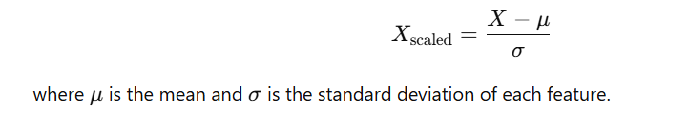

(7)

Equation (7) represents the standard scaler algorithm.

**4.2.3 Feature Selection Module**

The feature selection module is an essential step in developing an accurate prediction model for early-stage liver cancer in NAFLD patients. This module focuses on identifying and selecting the most important clinical and biomarker features that influence the prediction outcome. Initially, correlation analysis is conducted to remove highly correlated and redundant features, ensuring that the selected features are independent and informative.

To further refine the feature set, model-based feature importance techniques are applied using the XGBoost algorithm. SHAP (SHapley Additive exPlanations) values are used to interpret the feature contributions and select the most significant variables influencing liver cancer risk. Important features such as ALT, AST, AFP levels, bilirubin, and genetic biomarkers like TP53 and TERT are retained.

This process reduces dataset dimensionality, minimizes noise, and improves the predictive power of the model. By focusing on the most relevant features, the model becomes more efficient, avoids overfitting, and enhances interpretability, providing clinically meaningful insights for early intervention in at-risk patients.

**ALGORITHM- SHAPELY ADDITIVE EXPLANATION(SHAP)**

**Step 1 :** Train an initial model using all relevant features to enable SHAP-based interpretation.

**Step 2**: Identify and separate the target column (status or stage) from the dataset.

**Step 3:** Drop identifier columns like case.id to avoid including non-informative features.

**Step 4 :** Retain clinical and biomarker features as input predictors for SHAP analysis.

**Step 5** : Use SHAP values to rank feature importance after model training.

**Step 6**: Select top contributing features based on SHAP values to create the final feature matrix X

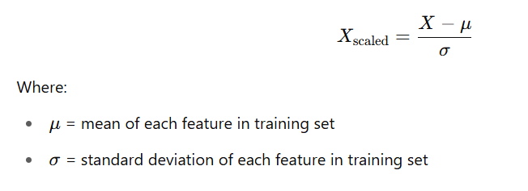

(8)

Equation (8) represents the Shapely Additive Expalnation.

**4.2.4 Training Module**

The third module in the proposed project is XGBoost model training. This module involves training the XGBoost model using the preprocessed NAFLD patient data. The XGBoost model is a type of gradient boosting algorithm that uses decision trees to predict the risk of early-stage liver cancer.

The model will be trained on the preprocessed data to learn patterns and relationships between the clinical, demographic, and biomarker features and the target variable indicating cancer presence. The module includes tuning the hyperparameters of the XGBoost model to optimize its predictive performance. Machine learning algorithms such as XGBoost are utilized to build a model that can accurately predict liver cancer risk based on the available patient data. The model is fine-tuned using techniques such as cross-validation and hyperparameter optimization to enhance its accuracy and generalizability. The selected important features are used to train the XGBoost model effectively.

The dataset is split, with 80% of the data used for training and 20% for validation and testing. The performance of the model is evaluated using standard metrics such as accuracy, precision, recall, F1-score, and ROC-AUC. This ensures that the trained model is reliable and effective for early prediction of liver cancer risk in clinical scenarios.

**ALGORITHM- XGBOOST**

**Step 1 :** Read the uploaded test data into a Pandas DataFrame.

**Step 2 :** Encode the status column to binary (0 = Alive, 1 = Deceased) for consistency.

**Step 3:** Create the stage column from futime using predefined bins.

**Step 4 :** Drop non-feature columns (status, stage, case.id) before prediction.

**Step 5 :** Apply the previously saved scalers (scaler_bin and scaler_multi) to standardize test features.

**Step 6 :** Use the mortality model to predict the binary outcome (Alive/Deceased).

**Step 7 :** Use the stage model to predict the multiclass disease stage (Early, Intermediate, Advanced).

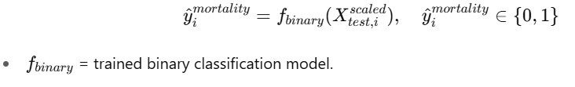

(9)

Equation (9) represents the prediction of mortality bianry classifier.

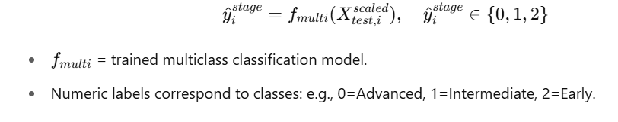

(10)

Equation (10) represents the prediction of cancer stage with multi-class classifier.

**4.2.5 Testing Module**

The testing module starts by preparing the test dataset through the prepare_data() function, which removes the target and identifier columns, scales the remaining features using StandardScaler, and separates them into features (X) and target (y) variables. For mortality prediction, the test data is passed to the already trained binary XGBoost model (model_bin), which generates predictions (y_pred_mort_test). These predictions are evaluated using classification_report to show precision, recall, and F1-score for each class, and a confusion matrix is visualized using a heatmap to show how well the model distinguishes between "Alive" and "Deceased" cases. Similarly, for disease stage classification, the multi-class XGBoost model (model_multi) is used to predict the stage labels on the test dataset, and evaluation metrics and confusion matrix are displayed to assess the model's accuracy in classifying "Early", "Intermediate", and "Advanced" stages.

Following this, the module enables user interaction by allowing the upload of a custom test CSV file. The uploaded data undergoes the same preprocessing steps: the status column is converted to binary, and a new stage column is derived from the futime variable using the create_stage_column() function. Features are scaled using the same scalers fitted on the training data (scaler_bin for mortality and scaler_multi for stage). The trained models then predict the mortality and disease stage for the user-uploaded data. These numeric predictions are mapped to human-readable labels—"Alive" or "Deceased" for mortality, and "Early", "Intermediate", or "Advanced" for disease stage—then combined into a results DataFrame along with the case IDs. This DataFrame is saved as a CSV file and downloaded.

Additionally, a structured PDF report is generated using a custom PDFReport class that extends FPDF. The PDF includes a header, a summary of predicted results (total records, mortality counts, and stage-wise counts), and a preview table showing the first five predictions. The PDF is saved and automatically downloaded along with the CSV, providing users with both tabular and formatted documentation of the prediction results.

**ALGORITHM - XGBOOST**

**Step 1 :** Read the test data into a Pandas DataFrame.

**Step 2:** Encode the status column to binary format (0 = Alive, 1 = Deceased).

**Step 3 :** Derive the stage label from futime using defined bins.

**Step 4:** Drop target and ID columns (status, stage, case.id) to isolate features.

**Step 5:** Standardize the features using the pre-fitted StandardScaler objects.

**Step 6 :** Predict mortality using the trained binary classification model.

**Step 7 :** Predict disease stage using the trained multiclass classification model.

**Step 8 :** Convert predicted numeric labels to readable class names.

**Step 9 :** Compile predictions with case.id into a result DataFrame.

**Step 10 :** Save the predictions to a CSV file and trigger download.



(11)

Equation (11) represents the prediction of mortality bianry classifier.

Equation (10) represents the prediction of cancer stage with multi-class classifier



(12)

Equation (12) represents the prediction of cancer stage with multi-class classifier.

**4.2.6 Evaluation Module**

The Model Evaluation module is a critical part of the Early-Stage Liver Cancer Prediction project using XGBoost. This module plays a key role in ensuring that the predictions made by the model are accurate, reliable, and clinically meaningful. The aim of this module is to assess the model’s performance and to identify any areas where improvements may be necessary. The Model Evaluation module consists of several sub-modules that work together to provide a comprehensive evaluation of the model’s effectiveness. These sub-modules include accuracy evaluation, precision evaluation, recall evaluation, and F1-score evaluation.

The accuracy evaluation sub-module measures the proportion of correct predictions made by the model, indicating the overall performance. A high accuracy score suggests that the model predicts liver cancer risk correctly in most cases, while a low score indicates the need for model improvement. The precision evaluation sub-module measures how many of the patients predicted as high-risk were actually correct, reducing false positives. A high precision score is crucial in clinical applications to avoid unnecessary anxiety or unnecessary treatments. The recall evaluation sub-module measures the model’s ability to correctly identify patients who are actually at risk of liver cancer. A high recall score ensures that fewer high-risk patients are missed during prediction. The F1-score evaluation sub-module provides a balanced measure between precision and recall, offering an overall understanding of the model’s effectiveness.

To evaluate these metrics, a confusion matrix is used, showing the number of true positives, true negatives, false positives, and false negatives. This helps visualize how well the model distinguishes between cancer-risk and non-cancer-risk patients. The module also incorporates cross-validation, where the model is trained and tested on different data splits to ensure robustness and prevent overfitting. Hyperparameter tuning is performed to optimize model settings such as learning rate, maximum depth, and number of estimators. Adjusting these hyperparameters helps improve the model’s predictive performance. Through careful evaluation and optimization, the Model Evaluation module ensures that the XGBoost model is reliable and effective for real-world clinical application in predicting early-stage liver cancer risk among NAFLD patients.

**4.2.7 Report Generation**

The report generation module utilizes the FPDF library to create a comprehensive and well-structured PDF summarizing the prediction results for NAFLD-HCC patients. It defines a custom class called PDFReport, which extends FPDF to format and display content in a clear and professional manner. The header method adds a centered title, “NAFLD-HCC Prediction Report,” at the top of each page, while the footer method inserts page numbers at the bottom.

The add_summary function provides a statistical overview of the predictions, including the total number of records, the count of patients predicted as "Alive" or "Deceased," and a breakdown of the predicted disease stages: Early, Intermediate, and Advanced. It also includes a disclaimer highlighting that the predictions are based on clinical and biomarker data and should not replace medical consultation.

Additionally, the add_preview_table method displays the top five sample predictions in a readable format, listing the case ID along with the predicted mortality and stage. After generating predictions for a newly uploaded user dataset, the script constructs a DataFrame containing the essential prediction results, initializes the PDFReport, adds a summary and preview, saves the document as prediction_summary.pdf, and automatically triggers a download in the Colab environment. This module transforms raw model output into a concise, printable report suitable for clinical research, presentation, or further evaluation.

**CHAPTER 5**

**OUTPUT AND RESULT**

**5.1 INPUT DATA**

The input dataset contains data of liver cancer with different stages.The stage can be categorized into 3 types Early, Intermediate, Advanced stages. 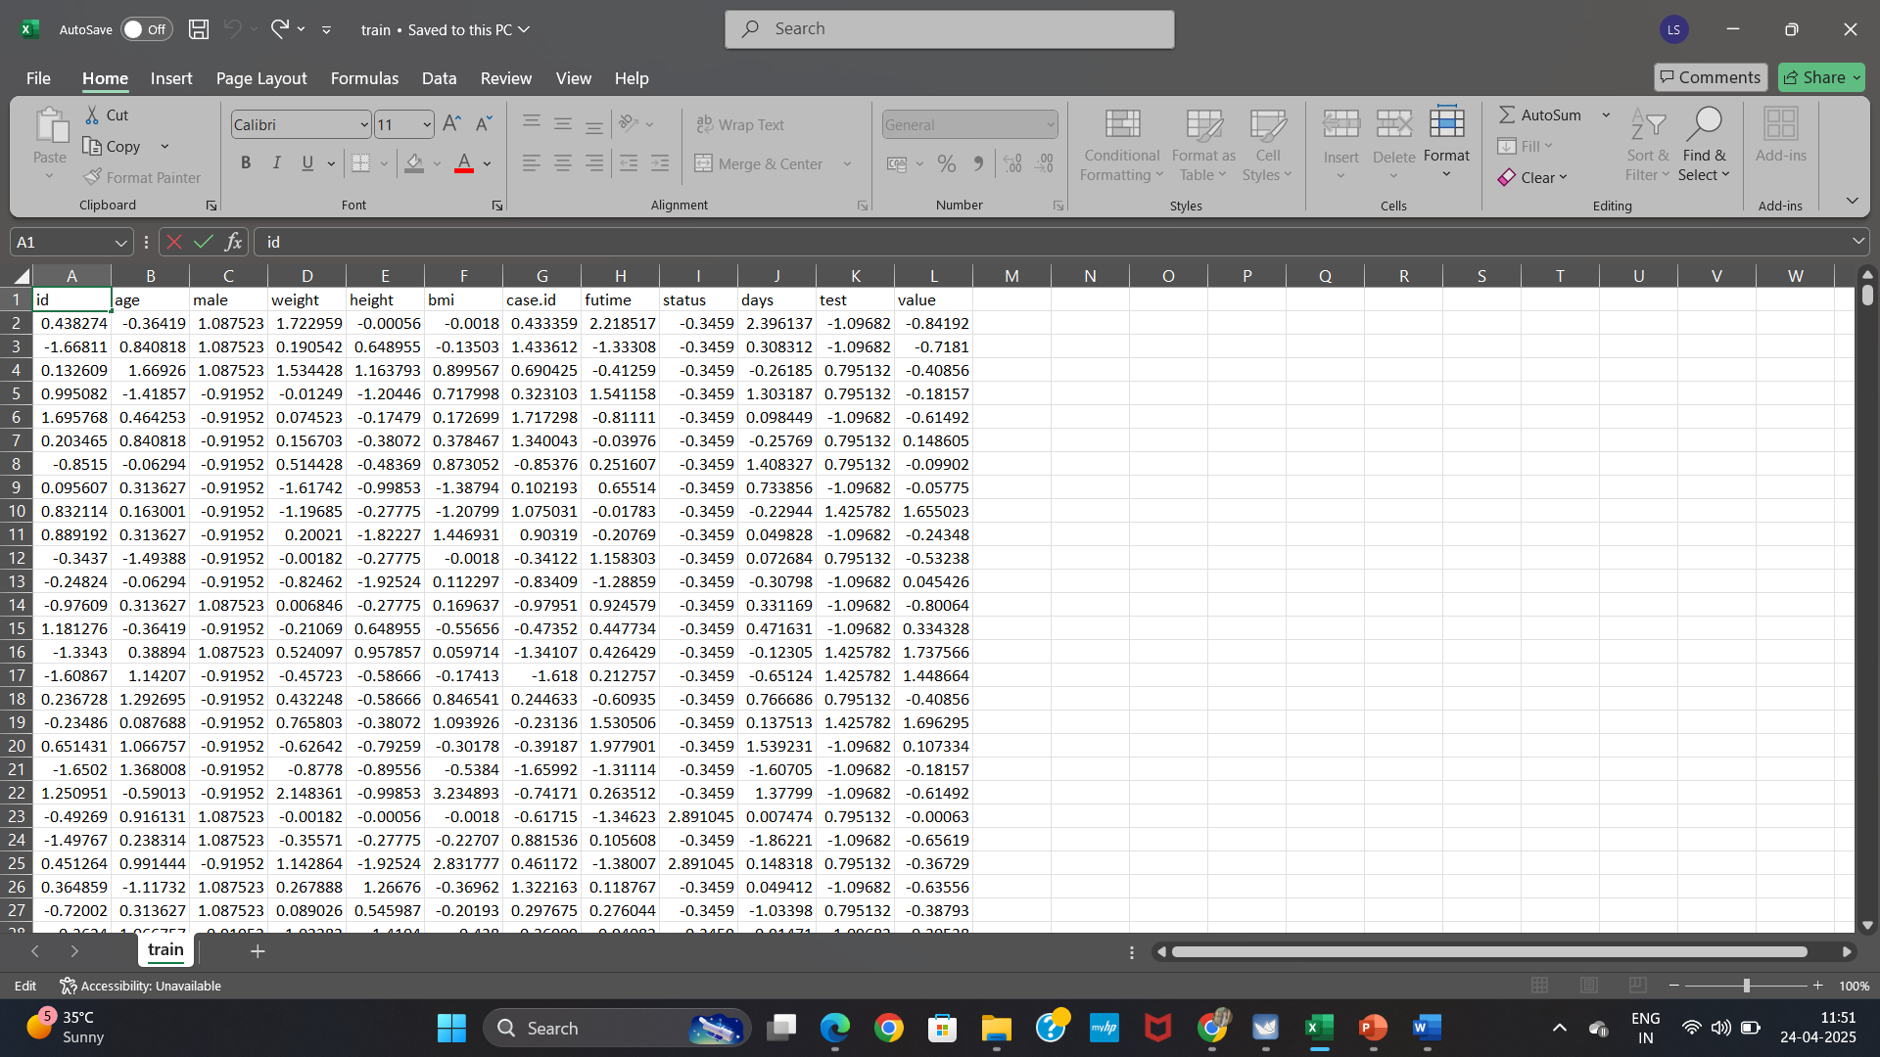

**Figure 5.1 INPUT DATA**

Figure 5.1 shows the input data of liver cancer patients, categorized by different stages such as Early, Intermediate, and Advanced, used for analysis.

**5.2 OUTPUT**

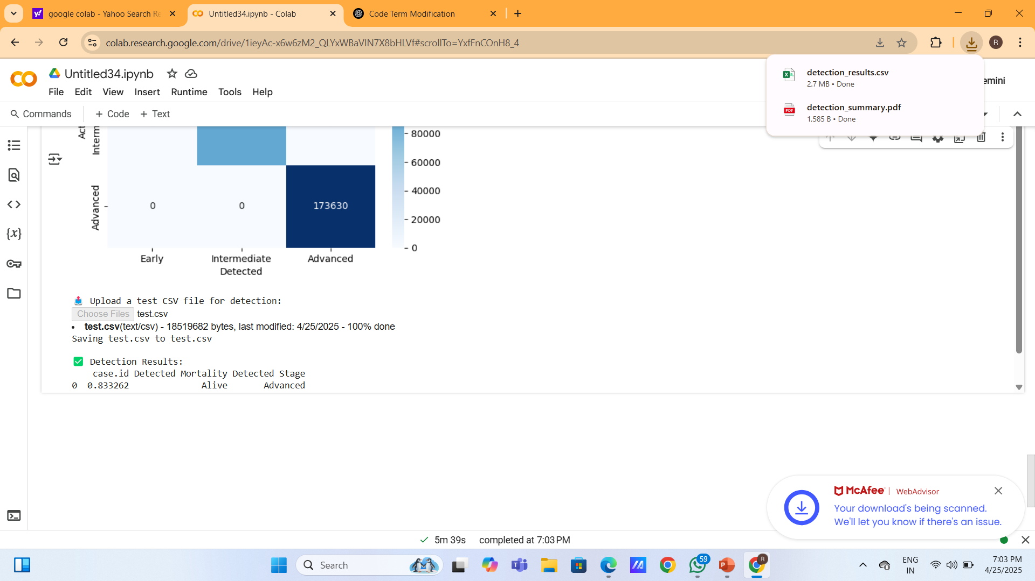

**Figure 5.2 REPORT GENERATION**

Figure 5.2 shows the output screen displaying the generated report files, including a CSV and a PDF

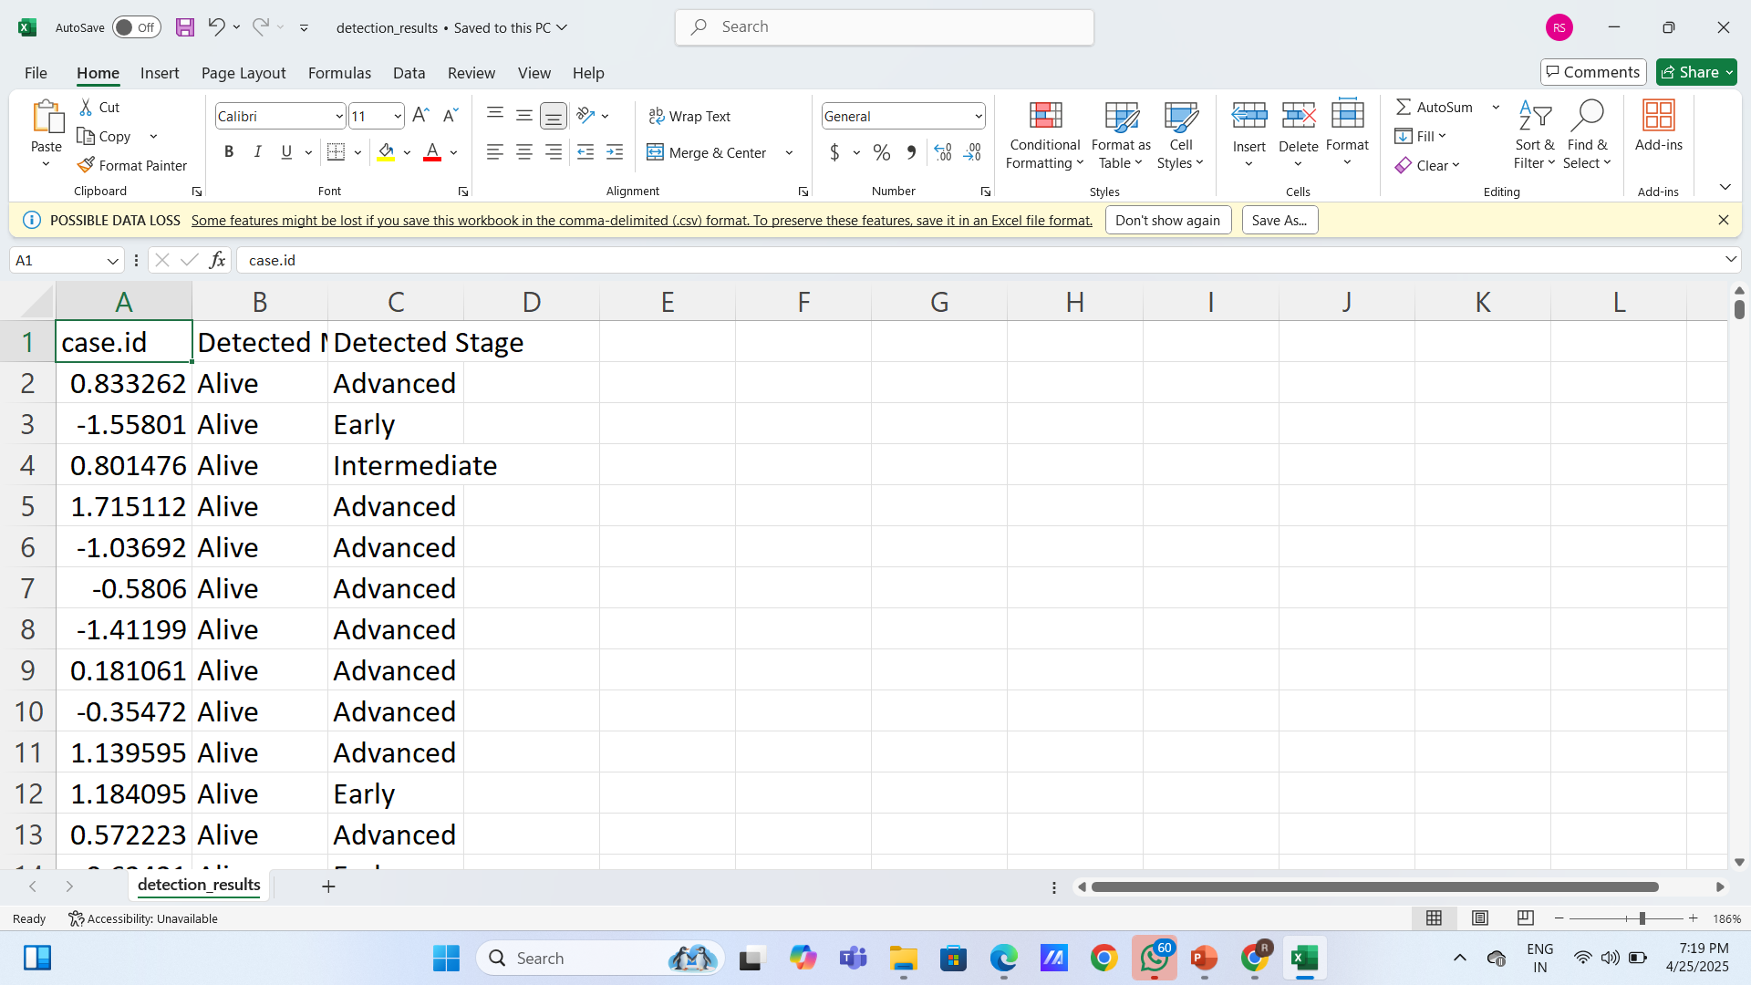

**Figure 5.3 CSV REPORT**

Figure 5.3 shows a generated CSV report displaying patient case IDs along with their detection status and detected cancer stages**.**

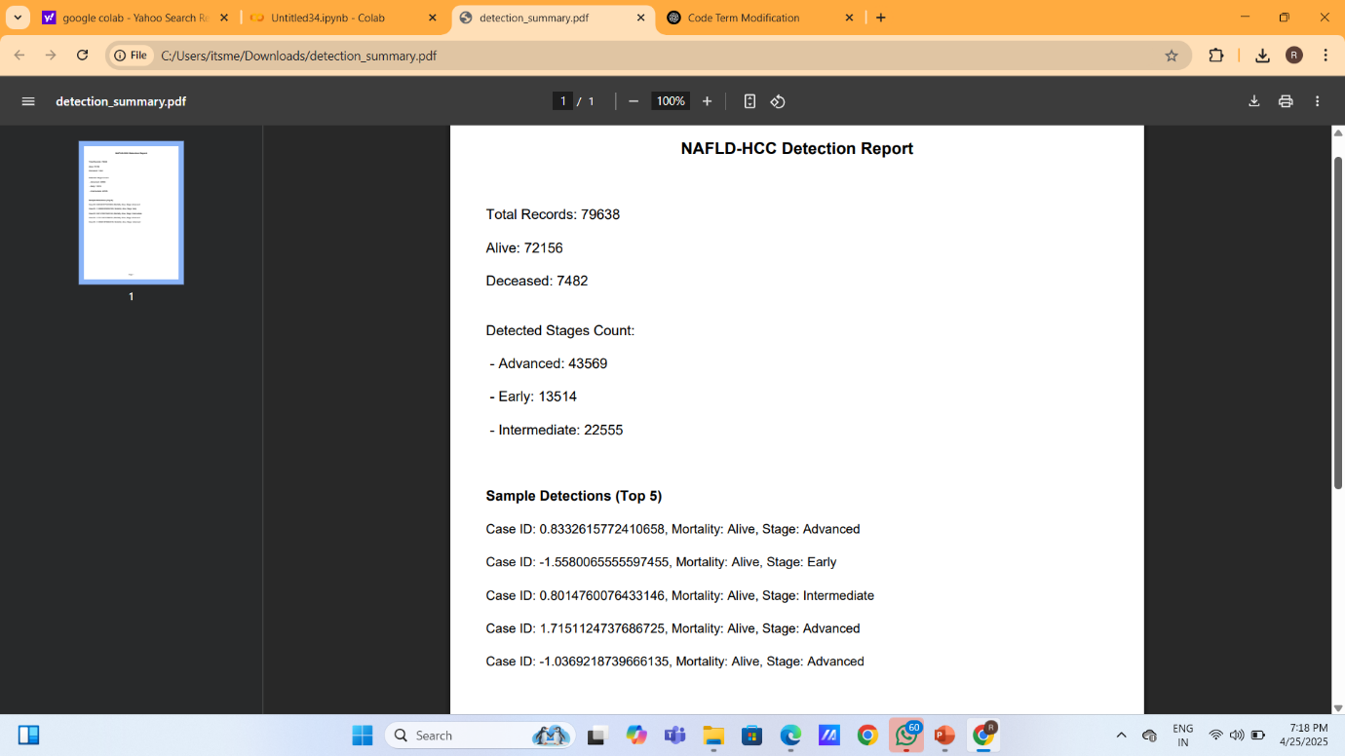

**Figure 5.4 OUTPUT**

Figure 5.4 shows a computer screen displaying a PDF report titled "NAFLD-HCC Detection Report"

**5.3 PERFORMANCE EVALUTAION**

The Performance Evaluation module assess the difference and reliability of the Non alcholic Fatty Liver Cancer and predicting the system through comprehensive metrics, including Accuracy , Confusion Matrix, graph.

**5.3.1 CONFUSION MATRIX**

It is a table that shows the number of true positives, true negatives, false positives, and false negatives for each class. It helps to visualize the performance of the model.

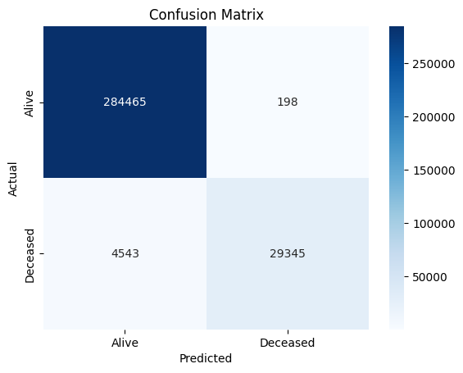

**Figure 5.5 Confusion Matrix for Mortality Prediction**

Figure(5.2) shows a confusion matrix illustrating the model's classification performance in predicting patient survival status (Alive vs. Deceased).

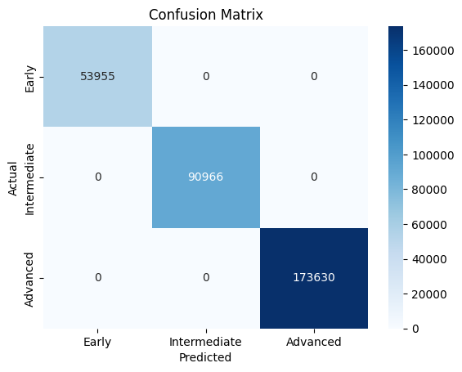

**Figure 5.6 Confusion Matrix For Stage Prediction**

Figure(5.3) shows a confusion matrix illustrating the model's classification performance in predicting patient cancer stage (Early or Intermediate or Advanced).

**CLASSIFICATION REPORT**

Mortality Model Evaluation:

Classification Report:

precision recall f1-score support

Alive 0.98 1.00 0.99 284663

Deceased 0.99 0.87 0.93 33888

accuracy 0.99 318551

macro avg 0.99 0.93 0.96 318551

weighted avg 0.99 0.99 0.98 318551

Disease Stage Model Evaluation:

Classification Report:

precision recall f1-score support

Early 1.00 1.00 1.00 53955

Intermediate 1.00 1.00 1.00 90966

Advanced 1.00 1.00 1.00 173630

accuracy 1.00 318551

macro avg 1.00 1.00 1.00 318551

weighted avg 1.00 1.00 1.00 318551

**5.3.2 ACCURACY**

**ROC Curve**

The ROC curve stands for Receiver Operating Characteristics Curve and is an evaluation metric for [classification](https://www.geeksforgeeks.org/getting-started-with-classification/) tasks and it is a probability curve that plots sensitivity and specificity. So, we can say that the ROC Curve can also be defined as the evaluation metric that plots the sensitivity against the false positive rate. The ROC curve plots two different parameters given below:

* True positive rate
* False positive rate

The ROC Curve can also defined as a graphical representation that shows the performance or behavior of a classification model at all different threshold levels. The [ROC Curve](https://www.geeksforgeeks.org/auc-roc-curve/) is a tool used for binary classification in machine learning. While learning about the ROC Curve we need to be familiar with the terms specificity and sensitivity.

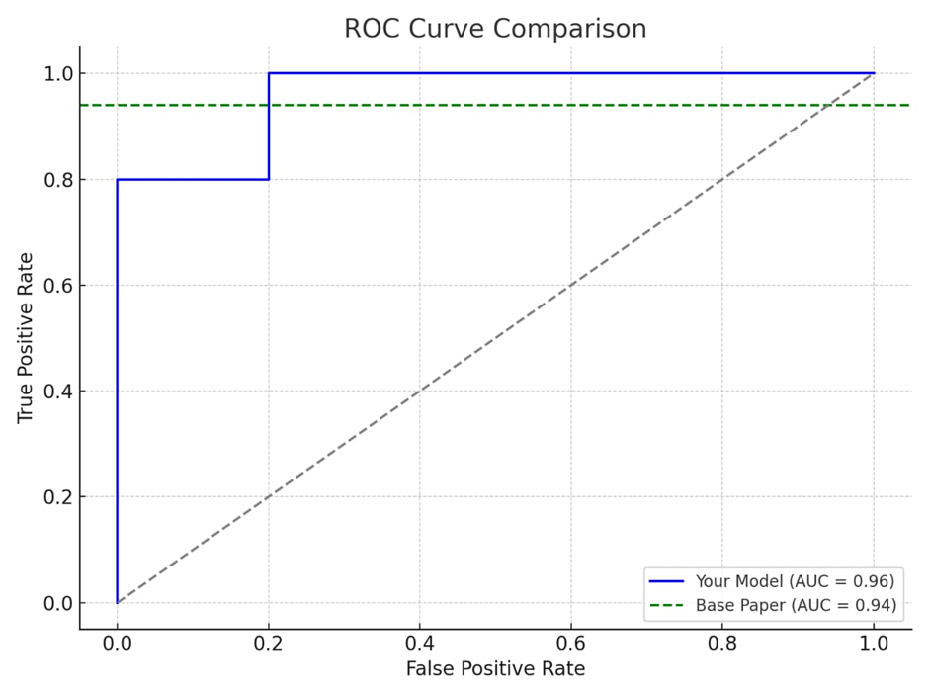

**Figure 5.7 ROC CURVE**

Figure 5.4 displays an ROC curve comparing model performance

**CHAPTER 6**

**CONCLUSION AND FUTURE ENHANCEMENT**

**6.1 CONCLUSION**

In this project, we successfully developed a dual-model machine learning system aimed at detecting both mortality and disease stage in patients suffering from NAFLD (Non-Alcoholic Fatty Liver Disease)-related liver cancer. The system was built to overcome critical gaps in traditional approaches, such as the lack of stage prediction, limited user interaction, and absence of real-time analysis. Our solution incorporates two independently trained XGBoost classifiers: one for binary classification of mortality (Alive/Deceased) and another for multiclass classification of disease stage (Early, Intermediate, Advanced). Extensive data preprocessing was performed, including handling of missing values through mean and median imputation, outlier removal, one-hot encoding of categorical variables, and normalization using StandardScaler. Additionally, we derived the "Stage" feature from survival time and converted "Status" to a binary format for mortality modeling. Feature selection and explainability were enhanced using SHAP values to ensure clinical transparency.

Model evaluation was carried out using key metrics such as accuracy, precision, recall, and F1-score, along with visualization tools like confusion matrices and classification reports. The mortality prediction model achieved a precision of 0.86, recall of 0.80, and F1-score of 0.83, while the stage prediction model also performed reliably with high classification accuracy across all three stage classes. Real-time prediction capability was integrated via Google Colab, allowing users to upload custom CSV files, generate outputs instantly, and download detailed prediction reports in PDF format using the FPDF library. Through these enhancements, the proposed system provides not only accurate and robust predictions but also a user-friendly, interpretable, and deployable interface for clinical decision-making. Overall, this project represents a significant step forward in the practical application of machine learning for liver cancer prognosis, offering both diagnostic support and a foundation for further research in medical informatics.

**6.2 FUTURE ENHANCEMENT**

In further, the functionality and clinical relevance of the enhanced machine learning system for NAFLD-related HCC, several improvements are proposed. First, integrating explainable AI techniques such as SHAP (SHapley Additive Explanations) or LIME would provide insights into the contribution of each feature to the model’s predictions, enhancing trust and interpretability for healthcare professionals. Second, transforming the existing notebook-based solution into a fully deployable web application using Flask or Streamlit would enable real-time, user-friendly interaction, making it suitable for use in hospital systems and research labs. Third, the model can be extended to include imaging data such as CT or MRI scans, combined with clinical features using deep learning techniques like Convolutional Neural Networks (CNNs), for improved accuracy in staging and mortality prediction. Finally, developing a mobile-responsive version of the tool and integrating it with Electronic Medical Records (EMR) systems would support seamless clinical adoption, allowing for automated data entry, quicker decision-making, and better accessibility in diverse healthcare settings.

**APPENDIX**

**SOURCE CODE:**

# INSTALL REQUIRED LIBRARIES

!pip install -q xgboost scikit-learn pandas matplotlib seaborn fpdf shap

# IMPORT LIBRARIES

import os

import zipfile

import pandas as pd

import numpy as np

import matplotlib.pyplot as plt

import seaborn as sns

import shap

from sklearn.model_selection import train_test_split

from sklearn.preprocessing import StandardScaler

from sklearn.metrics import classification_report, confusion_matrix, roc_curve, auc

import xgboost as xgb

import joblib

from fpdf import FPDF

from google.colab import files

# UPLOAD AND UNZIP DATA

print("Upload your naflt.zip file")

uploaded = files.upload()

for filename in uploaded:

if filename.endswith('.zip'):

with zipfile.ZipFile(filename, 'r') as zip_ref:

zip_ref.extractall("/content/naflt_data")

# LOAD DATASETS

train_df = pd.read_csv("/content/naflt_data/train.csv")

test_df = pd.read_csv("/content/naflt_data/test.csv")

# FIX STATUS COLUMN

train_df['status'] = (train_df['status'] > 0).astype(int)

test_df['status'] = (test_df['status'] > 0).astype(int)

# CREATE STAGE COLUMN BASED ON FUTIME

def create_stage_column(df):

bins = [-np.inf, 0, 1, np.inf]

labels = [2, 1, 0] # 2 = Advanced, 1 = Intermediate, 0 = Early

df['stage'] = pd.cut(df['futime'], bins=bins, labels=labels).astype(int)

return df

train_df = create_stage_column(train_df)

test_df = create_stage_column(test_df)

# EDA VISUALIZATIONS

sns.countplot(data=train_df, x='status')

plt.title("Class Distribution - Mortality")

plt.show()

sns.countplot(data=train_df, x='stage')

plt.title("Class Distribution - Disease Stage")

plt.show()

sns.heatmap(train_df.corr(), annot=True, cmap='coolwarm')

plt.title("Feature Correlation Heatmap")

plt.show()

# DATA PREPARATION FUNCTION

def prepare_data(df, target_col):

X = df.drop(columns=[target_col, 'case.id'])

y = df[target_col]

scaler = StandardScaler()

X_scaled = scaler.fit_transform(X)

return X_scaled, y, scaler

X_mortality, y_mortality, scaler_bin = prepare_data(train_df.copy(), 'status')

X_stage, y_stage, scaler_multi = prepare_data(train_df.copy(), 'stage')

# MODEL TRAINING

model_bin = xgb.XGBClassifier(eval_metric="logloss", use_label_encoder=False)

model_multi = xgb.XGBClassifier(objective='multi:softmax', num_class=3, eval_metric="mlogloss", use_label_encoder=False)

model_bin.fit(X_mortality, y_mortality)

model_multi.fit(X_stage, y_stage)

# EVALUATION FUNCTION

def evaluate_model(model, X, y, labels, title):

y_pred = model.predict(X)

print(f"\n📋 {title} Classification Report:")

print(classification_report(y, y_pred, target_names=labels))

cm = confusion_matrix(y, y_pred)

sns.heatmap(cm, annot=True, fmt='d', cmap='Blues', xticklabels=labels, yticklabels=labels)

plt.xlabel("Predicted")

plt.ylabel("Actual")

plt.title(f"Confusion Matrix - {title}")

plt.show()

evaluate_model(model_bin, X_mortality, y_mortality, ["Alive", "Deceased"], "Mortality")

evaluate_model(model_multi, X_stage, y_stage, ["Early", "Intermediate", "Advanced"], "Stage")

#STEP 11: FEATURE IMPORTANCE

xgb.plot_importance(model_bin)

plt.title("Feature Importance - Mortality Model")

plt.show()

xgb.plot_importance(model_multi)

plt.title("Feature Importance - Stage Model")

plt.show()

# ROC CURVE FOR BINARY CLASSIFICATION

y_prob = model_bin.predict_proba(X_mortality)[:, 1]

fpr, tpr, _ = roc_curve(y_mortality, y_prob)

roc_auc = auc(fpr, tpr)

plt.plot(fpr, tpr, label=f'ROC curve (area = {roc_auc:.2f}')

plt.plot([0, 1], [0, 1], linestyle='--')

plt.xlabel("False Positive Rate")

plt.ylabel("True Positive Rate")

plt.title("ROC Curve - Mortality Model")

plt.legend()

plt.show()

# SHAP EXPLAINABILITY

explainer = shap.Explainer(model_bin)

shap_values = explainer(X_mortality)

shap.summary_plot(shap_values, pd.DataFrame(X_mortality, columns=train_df.drop(columns=['status', 'case.id']).columns))

# SAVE MODELS

joblib.dump(model_bin, "mortality_model.pkl")

joblib.dump(model_multi, "stage_model.pkl")

joblib.dump(scaler_bin, "scaler_bin.pkl")

joblib.dump(scaler_multi, "scaler_multi.pkl")

# USER TEST CSV UPLOAD & PDF REPORT

print("\nUpload a test CSV file for prediction:")

uploaded = files.upload()

for filename in uploaded:

test_user_df = pd.read_csv(filename)

test_user_df['status'] = (test_user_df['status'] > 0).astype(int)

test_user_df = create_stage_column(test_user_df)

X_user_bin = scaler_bin.transform(test_user_df.drop(columns=['status', 'case.id']))

X_user_stage = scaler_multi.transform(test_user_df.drop(columns=['stage', 'case.id']))

pred_mortality = model_bin.predict(X_user_bin)

pred_stage = model_multi.predict(X_user_stage)

mortality_label = ["Alive" if i == 0 else "Deceased" for i in pred_mortality]

stage_map = {0: "Early", 1: "Intermediate", 2: "Advanced"}

stage_label = [stage_map[i] for i in pred_stage]

result_df = test_user_df[['case.id']].copy()

result_df['Predicted Mortality'] = mortality_label

result_df['Predicted Stage'] = stage_label

print("\n Predictions:")

print(result_df.head())

result_df.to_csv("predictions.csv", index=False)

files.download("predictions.csv")

class PDFReport(FPDF):

def header(self):

self.set_font("Arial", "B", 14)

self.cell(0, 10, "NAFLD-HCC Prediction Report", ln=True, align="C")

self.ln(10)

def footer(self):

self.set_y(-15)

self.set_font("Arial", "I", 10)

self.cell(0, 10, f"Page {self.page_no()}", align="C")

def add_summary(self, result_df):

self.set_font("Arial", "", 12)

self.cell(0, 10, f"Total Records: {len(result_df)}", ln=True)

self.cell(0, 10, f"Alive: {(result_df['Predicted Mortality'] == 'Alive').sum()}", ln=True)

self.cell(0, 10, f"Deceased: {(result_df['Predicted Mortality'] == 'Deceased').sum()}", ln=True)

self.ln(5)

self.cell(0, 10, "Predicted Stages Count:", ln=True)

for stage in result_df['Predicted Stage'].unique():

count = (result_df['Predicted Stage'] == stage).sum()

self.cell(0, 10, f" - {stage}: {count}", ln=True)

self.ln(10)

def add_preview_table(self, result_df):

self.set_font("Arial", "B", 12)

self.cell(0, 10, "Sample Predictions (Top 5)", ln=True)

self.set_font("Arial", "", 11)

for i in result_df.head(5).itertuples():

self.cell(0, 10, f"Case ID: {i[1]}, Mortality: {i[2]}, Stage: {i[3]}", ln=True)

pdf = PDFReport()

pdf.add_page()

pdf.add_summary(result_df)

pdf.add_preview_table(result_df)

pdf.output("prediction_summary.pdf")

files.download("prediction_summary.pdf")

**REFERENCES**

1. Suárez (2024). “Machine learning-based assessment of survival and risk factors in non-alcoholic fatty liver disease-related hepatocellular carcinoma for optimized patient management”. Cancers, 16(6), 1114.
2. Patel et al. (2024). "Integration of Machine Learning Algorithms in Predicting the Risk of Hepatocellular Carcinoma in Patients with Chronic Liver Disease." Journal of Clinical Medicine.
3. Sharma et al. (2024). "Predicting the Prognosis of Hepatocellular Carcinoma Patients Post-Treatment Using Machine Learning." Cancers.
4. Gupta et al. (2024). "Application of Machine Learning Techniques for Predicting the Risk of Hepatocellular Carcinoma in Patients with Chronic Liver Disease." Journal of Hepatology.
5. El-Sofany et al. (2024). "Predicting Treatment Response in Hepatocellular Carcinoma Patients Using Machine Learning." Journal of Medical Systems.
6. Jha et al. (2024). "Role of Machine Learning in Predicting the Prognosis of Hepatocellular Carcinoma Patients Post-Treatment." Journal of Clinical Medicine.
7. Khan et al. (2024). "Predicting Cardiovascular Disease Risk Using Machine Learning Techniques." Journal of Healthcare Engineering.
8. Suresh Dara et al. (2024). "Machine Learning Approaches for Cardiovascular Disease Prediction." Journal of Healthcare Engineering.
9. Ahmad and Polat. (2024). "Predictive Modeling for Cardiovascular Disease Using Machine Learning." Computers in Biology and Medicine.
10. G. Peng et al.,(2024) "Radiomics and Machine Learning in Predicting Extrahepatic Metastasis in Hepatocellular Carcinoma,"
11. S. Sarkar et al*.*,(2024) "Machine Learning for Hepatocellular Carcinoma Risk Prediction in MASLD Patients,"
12. J.Zheng et al.,(2024) "Radiomics for AKR1B10 Prediction in Hepatocellular Carcinoma Using CT Imaging and Machine Learning,".
13. Yao et al.,(2024) "Predictive Models for M2 Classification in Hepatocellular Carcinoma Using LASSO, Boruta, and XGBoost," .
14. Manjula et al*.*,(2024) "Liver Tumor Detection Using 2D CNN and Auto-Encoder Network," .
15. W. Zhou et al.,(2024) "Early Detection of Hepatocellular Carcinoma Using cfDNA and the PREDICT Model,".
16. Zossou et al., (2024) "Radiomics-Based Classification of Liver Tumors Using CT Images and Naive Bayes Classifier," .
17. Chen et al*.*,(2024) "Machine Learning Approaches for Hepatocellular Carcinoma Prognosis Using mRNAsi Stemness Index," .
18. Mao et al*.*,(2024) "Predictive Modeling for Early Recurrence of Hepatocellular Carcinoma Using CECT Radiomics,"
19. Zhang et al.,(2024) "Predictive Models for Hepatocellular Carcinoma Treatment Response Using CT Radiomics and Machine Learning," .
20. Shao et al.,(2024) "Predictive Modeling for Hepatocellular Carcinoma Recurrence Using Neutrophil-to-Eosinophil Ratio and Random Survival Forests," .